(Approx. 632 words)

Photography: Size does matter, Part 2
By David Stonier-Gibson, Editor, Melbourne PCUG, Australia
May 2018 issue, >PC_Update
www.melb-pc.org.au
editorpc (at) melbpc.org.au

Last month I argued that a large image sensor (millimetres, not pixels) is desirable. Now I present arguments for the opposite. A contradiction? You decide.

When you hold a magnifying glass up to the sun to burn a hole in a leaf, the distance between the glass and the leaf where the sun spot is at its smallest and hottest is called the focal length of the lens.

You may also have noticed, or you can intuit, that the larger the lens the more sunlight it will gather and the better it will burn. The focal length of a lens divided by its diameter is called the f-stop, or aperture, or sometimes the speed of the lens. The larger the diameter, the smaller the f-stop number and the more light it can collect, say in a dark room, and project on to the image sensor. But if the scene is too bright, the lens may let in too much light. Every good lens is therefore fitted with an adjustable iris, that can block off adjustable amounts of the periphery of the lens. If the iris (more often called aperture) is closed off (“stopped down”) the effective lens diameter is reduced, and the f-number goes up. You may have seen terms like “f8”, which means the diameter of the hole in the iris is one eighth the focal length of the lens.
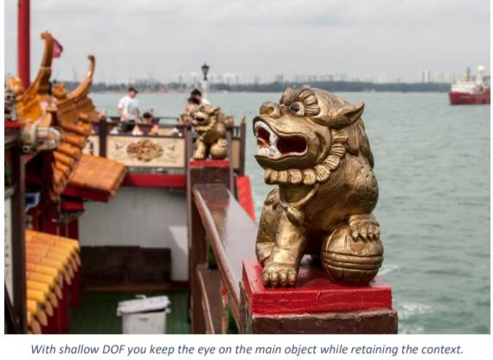
When you see those big white lenses capturing ball tampering at the cricket, they are like telescopes that can reach out across the pitch. They have very long focal lengths. 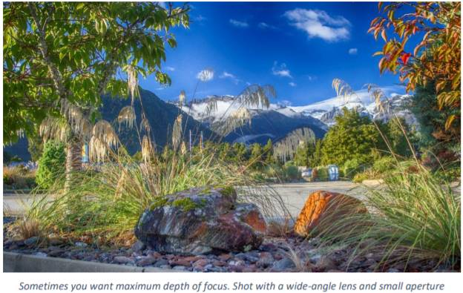

By contrast, George Skarbek on our cover photo is shooting with a wide angle, (short focal length) lens to capture a wide view of the party.
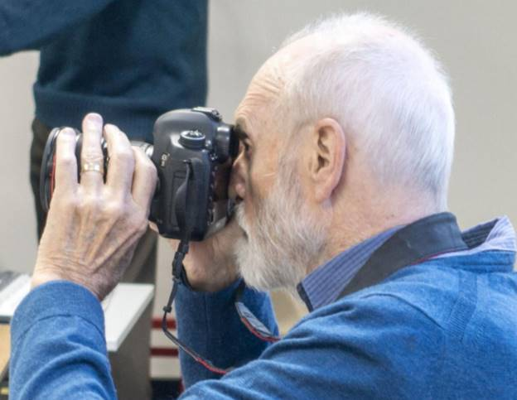

What would be considered a “normal” focal length, rather than telescopic or wide angle? Judgements on that vary a bit, but as a good rule of thumb a normal lens is one with a focal length equal to the diameter of the image sensor. That means that the larger the sensor the longer the focal length of a “normal” lens for that sensor. Now I must introduce Depth Of Focus (or field). DOF is a measure of the range of distances from the camera at which objects in the scene are rendered “in focus”, or “sharp” Say I focus on a child in the garden. Will the back fence be in focus? Will the bush in the foreground be in focus? Serious photographers take DOF very seriously. By using that third dimension they can focus (no pun intended) the viewer’s eye on the main item of interest in a picture. There are times when you want narrow DOF. There are other times when you aim for wide DOF.

DOF is determined by two factors: The f-stop or aperture, and the focal length of the lens. Large apertures (low f-stop numbers) reduce DOF. Long focal length (telephoto) lenses have less DOF than short focal length (wide angle) lenses. Experienced photographers know how to work with that knowledge to produce the most engaging pictures.

But what about the casual “snapshotter” with a phone camera, or low-end point and shoot camera? Why is it that they manage to get nice “clear” pictures much of the time? The reason is that in a phone there is no space for a large sensor and matching long focal length lens. So, the sensor must be small. And the lens will have a correspondingly very short focal length and consequent large DOF. That means sharper pictures overall. Phone cameras generally don’t have an iris, so they are always shooting “wide open”, but the very short focal length dominates in the DOF stakes.



